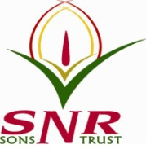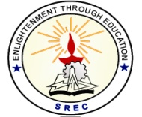**SRI RAMAKRISHNA ENGINEERING COLLEGE**

[Educational Service: SNR Sons Charitable Trust]

[Autonomous Institution, Accredited by NAAC with ‘A’ Grade]

[Approved by AICTE and Permanently Affiliated to Anna University, Chennai]

[ISO 9001:2015 Certified and all eligible programmes Accredited by NBA]

**VATTAMALAIPALAYAM, N.G.G.O. COLONY POST, COIMBATORE – 641 022**

**SREC – IP CELL**

**Date: 03.08.2021**

**Report on Webinar on Patent Intelligence:**

A webinar on ‘Elevate your patent landscape to patent intelligence' has been conducted on 3 August 2021 for the faculty of Sri Ramakrishna Engineering College which was more insightful about Derwent Data Analyzer. This webinar attempted to discuss approaches to elevate a traditional patent landscape into patent intelligence.

**Topics covered are:**

* Understanding traditional landscape and its limitations
* Need for patent intelligence and customization for different personas (R&D, Legal, IP, Academia, Start-up)
* The value of multi-dimensional visualization
* Turning landscape to intelligence through Derwent Data Analyzer
* Case studies

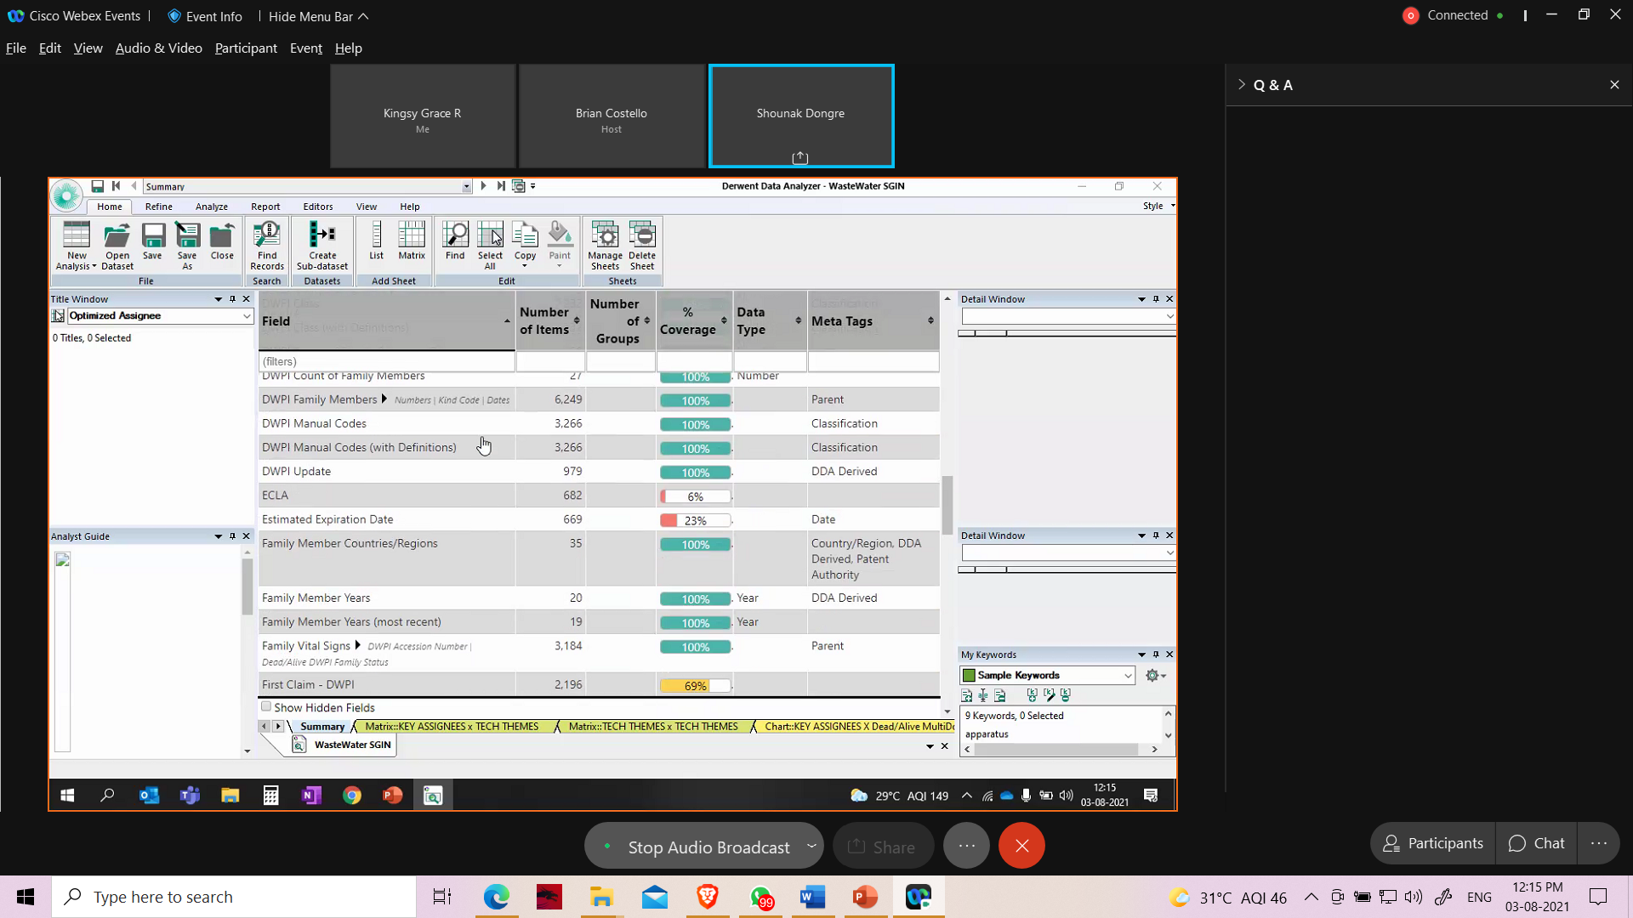

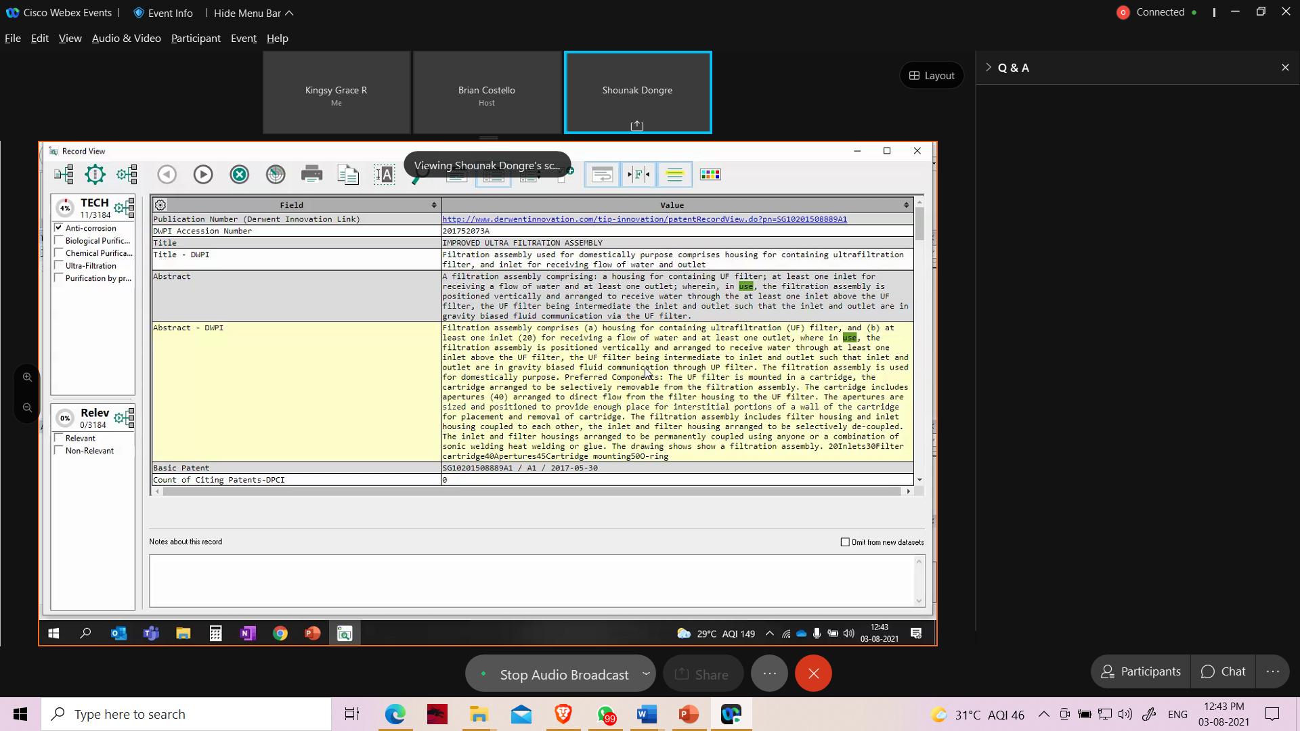

**HEAD – IP CELL**

**Dr. M. S. Geetha Devasena, P/CSE**